‘

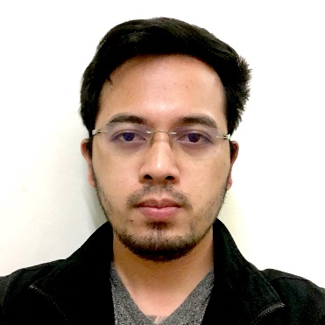

Brgy.Lumingon

Tiaong, Quezon

+63 917 124 1870

houwaey@gmail.com

JOHN PAULO MARQUEZ

|  |  |  |
| --- | --- | --- |
| Summary |  | Focused and detail-oriented Software Engineer offering exceptional troubleshooting skills and a talent for developing innovative solutions to unusual and difficult problems. |
| KEY SKILLS |  | JAVA, J2EE, Spring Framework, JUnit, Mockito, Hibernate, JPA, JSF, Servlets, WebService(REST/SOAP), JSON, PL/SQL, Maven, OracleDB, MySQL, Jasper, PrimeFaces, WebSphere, JBoss/WildFly |
| hightlights |  | * I’ve been assigned in West Africa (Ivory Coast, Gabon, and Benin) and Dubai for almost 3 years to support our Partners/Clients and to manage our Mobile Money System on-site. I’ve been assigned also to handle all the on-site developments including Core Applications / Integrations (using Java), Web Applications (using PHP) and manage Database (using Oracle) and Servers (Red Hat OS). * Experienced in JAVA - I was working on a certain projects using Java/Web Services (REST/SOAP/ISO8583) especially in Mobile Money System which is connected with the Third Party Applications such as Banks, Billers and Merchants. (7 years of experience) * Experienced in Oracle DB - we were using oracle as database to our Mobile Money System and other applications/solutions. We are also trained in database installation and database maintenance it such as clearing table spaces, archive logs, and other health checks. (5 years of experience) |
| ACCOMPLISHMENTS |  | * Designed, developed and produced Flooz, which was successfully implemented by Moov (part of Etisalat). * Designed, developed NowNow Mobile Money which was successfully implemented in Nigeria, Zimbabwe, Afghanistan, etc. * Designed, developed KFC Loyalty System which was successfully implemented on a certain branches here in Manila, Philippines as a pilot. * Developed several internal tools to automate mundane tasks that were quickly adopted by other developers. |
| Experience |  | Java systems analyst, sun life financial (yondu inc.) 10/2018 to Present   * Conducts system analysis, technical design and initial effort estimation. * Responsible for systems development and enhancements according to business requirements. * Participates in system testing (SIT) and supports user acceptance testing (UAT) * Participates in systems implementation * Conducts Systems troubleshooting * Provides system solutions where applicable * Prepare user procedure manual * Regularly submits status reports to Systems Developer Lead Updated, modified and expanded existing software programs. * Recommended and executed plans to improve development tools and processes. * Conducted technical reviews and trade-off studies. * Performed functional, non-functional, regression and performance tests.  Java developer II, bangko sentral ng pilipinas (collabera) 05/2018 to 10/2018   * Developed and maintained a Monitoring System (Web-Based Java Application) which will be used by the BSP (Internal). * Performed functional, non-functional, regression and performance tests  sENIOR SOFTWARE ENGINEER, PAYTYCHE SOLUTIONS INC. 07/2015 to 03/2017   * Drove continual improvement to system architecture by re-factoring old legacy code. * Collaborated with product and engineering team members to define and develop new product concepts. * Managed the road map for product design and development. * Led working groups to develop mitigation strategies and prepare standard operating procedures. * Updated, modified and expanded existing software programs. * Recommended and executed plans to improve development tools and processes. * Organized and held meetings with stakeholders, contractor product teams and customers. * Conducted technical reviews and trade-off studies. * Performed functional, non-functional, regression and performance tests.  SOFTWARE ENGINEER, TELCOM LIVE CONTENT INC. 04/2012 to 07/2015   * Coordinated with QA testers for end-to-end unit testing and post-production testing. * Implemented new payment API for company-wide deployment and integration with third parties. * Drafted technical documents, including white-papers. * Instrumented and modified unit and integration tests to improve software quality and reliability. * Resolved customer issues by establishing workarounds and solutions and by debugging and creating defect fixes. |
| Education |  | BAchelor of science: computer science (2012)Manuel s. enverga university foundation candelaria inc. - philippines  * Coursework in Computer Science. * Architectural Implications of Cloud Computing seminar. * Software Architecture coursework  high school diploma (2007)recto memorial national high school - philippinesElementary diploma (2003)claro m. recto memorial central school - philippines |